URL: https://adityabirlahospital.com/doctors/neurologist-in-pune

Meta Title: Best Neurologists In Pimpri Chinchwad, Pune | ABMH

Meta Description: Find the best neurologists in Pimpri Chinchwad at Aditya Birla Hospital. Expert care for brain, spine, and nervous system disorders. Book an appointment today!

Best Neurologist In Pimpri-Chinchwad Pune
Neurologists specialize in diagnosing and treating disorders of the nervous system, including the brain, spinal cord, and peripheral nerves. These neurology specialists manage a wide range of neurological conditions, from common headaches to complex neurological diseases, with precision and expertise.

Our Team of Leading Neurology Specialists in Pune
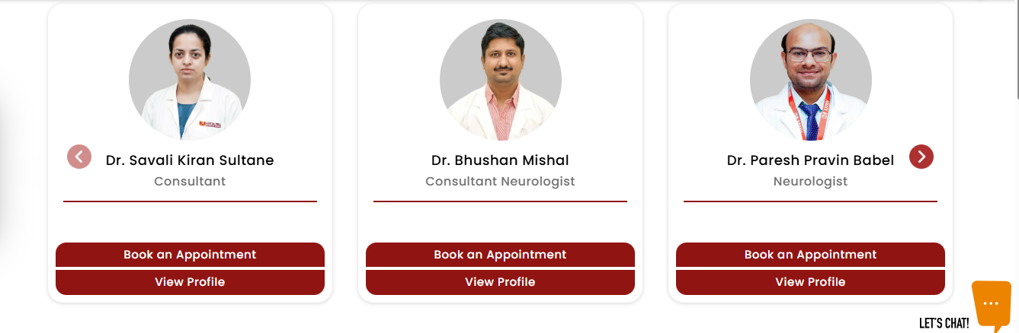

At Aditya Birla Memorial Hospital, our team of neurologists in Pimpri Chinchwad Pune is dedicated to providing comprehensive neurological care. Whether you are seeking a neurology doctor for issues such as headaches, seizures, or other neurological symptoms or need a paediatric neurologist for conditions like childhood epilepsy or motor skill concerns, our specialists are equipped to offer expert, personalized care for patients of all ages.

Our Neurologists Treat Many Conditions, Including
- Headache Management: Diagnosing and treating migraines, tension headaches, and cluster headaches.
- Epilepsy & Seizure Disorders: Comprehensive care for epilepsy, including medication management and surgical options.
- Stroke Care: Acute stroke management, rehabilitation, and prevention strategies.
- Parkinson’s Disease: Specialized treatment plans, including medication and therapy, for managing symptoms.
- Multiple Sclerosis (MS): Customized treatment and support for managing MS and its symptoms.
- Dementia & Alzheimers Disease: Diagnosis, treatment, and supportive care for cognitive impairments.
- Peripheral Neuropathy: Managing nerve pain and other symptoms associated with peripheral nerve disorders.
- Neuromuscular Disorders: Treatment for conditions affecting muscles and nerves, such as myasthenia gravis and ALS.
- Movement Disorders: Care for disorders like essential tremor, dystonia, and ataxia.
- Spinal Disorders: Treatment for neurological issues related to the spine, including herniated discs and spinal cord injuries.
- Paediatric Neurology: Specialized care for children with neurological conditions, including developmental delays and epilepsy.

- Sleep Disorders: Evaluation and management of conditions like sleep apnea, narcolepsy, and insomnia.

How Do I Find the Best Neurologist Near Me in Pune?

If you are searching for the best neurologist near you or a neurology specialist near you in PCMC our team of highly experienced neurologists offers a patient-centric approach to neurological care at our Neurology Hospital in Pimpri-Chinchwad Pune. You can easily reach our facility from nearby locations.

Nearby Locations:

Hinjewadi, Wakad, Baner, Aundh, Pimple Saudagar, Bhosari, Ravet, Chinchwad Gaon, Tathawade, Nigdi, PCMC, Pimpri, Moshi, and Chakan

